**multi-Touch-midAir-and Motion for Virtual and Augmented Reality (TAM) Version 6.0**

**Learning Data Structures with Augmented Reality for Computer Science Education (K-12)**

TOM LAM, and RAMSES SANCHEZ, Florida International University

**ABSTRACT**

Axiomatic learning is at the core of Computer Science Education. Prospective Computer Science students are often faced with a backlog of theory that, to the student, might not be so obvious in their utility. The field has a large barrier to entry; as demand for software developers grow, governments aim to introduce programming languages as part of earlier education, so tools will need to be developed to effectively target this demographic. In this paper a possible software solution in 3D-space is provided, aimed to increase student engagement and motivation to promote deep and interactive learning. As part of the TAM group at FIU, our work involves connecting people in virtual workspaces with respects to Computer Science education; we argue that the augmented reality domain of our software is prime space to achieve such a goal, since the virtual artifacts therein promote group learning as part of the Empirical Modelling and the nature of construals, with study the emergent properties of computational relations to detach them from their axiomatic roots.

Additional Key Words and Phrases:

Augmented Reality, Education, Learning, Computer Science Education, Data Structures, Empirical Modelling, Construals, Axiomatic, Technology, Visualization.

**ACM REFERENCE FORMAT**

P. Panda, A. Sengupta and K. Roy, "Conditional Deep Learning for energy-efficient and enhanced pattern recognition," 2016 Design, Automation & Test in Europe Conference & Exhibition (DATE), Dresden, 2016, pp. 475-480.

URL: http://ieeexplore.ieee.org/stamp/stamp.jsp?tp=&arnumber=7459357&isnumber=7459269

1. **INTRODUCTION**

Computer Science Education (CSE) is intrinsically axiomatic, based on fundamental mathematical and philosophical theorems, lemmas, and postulations. CSE is difficult to teach to students who are new to the subject either because the prerequisite fundamentals require rigorous study and commitment or because the material itself is not as engaging; topics like stacks, queues, *n* arrays (*2d*-plus), hash tables, and red-black trees – for example, are often abstract and hold little meaning until applied directly through programming assignments (which are necessarily assigned to reinforce theory). Our technologically connected, and computer-driven, world has increased the need for software developers – to whom, data structures, is an integral part of their CSE curriculum. Multi-touch-midair-and Motion for Virtual and Augmented Reality (TAM) Version 6.0 Learning Data Structures with Augmented Reality for Computer Science Education (K-12) seeks to bridge the gap between the teacher and the student, by creating a tool in which data structure concepts are presented in a clear, concise, and novel way to provide an interactive representation of topics that are not often not represented at all in 3D space.

This pare is organized as follows: Section 2 gives an overview of the current academic literature with respects to Education (methodologies and taxonomies), Augmented Reality, and Data Structures. Section 3 discusses a possible augmented reality software solution aimed at linking data structure visualizations and the educational frameworks while discussing possible ways to measure learning engagement, and, finally, we conclude in Section 4.

1. **LITERATURE REVIEW**

The potential of computer-aided tools in the learning environment is almost infinite. Indeed, computer systems, encompassing computer tutors, rudimentary artificial intelligence, and other technological tools, are about as effective as human tutoring [VanLEHN 2011]. Learning engagement can be measured biometrically using the advanced, analytic, and automated (AAA) approach to measure engagement using various technologies such as Kinect with depth mapping, pressure pads and pressure mads, Q-sensor with skin conductance output, eye tracker with gaze fixations, and facial feature tracking with the Computer Expression Recognition Toolbox [Sidney et al. 2017]. When judging the quality of learning, we will use the theoretical cognitive psychology ICAP Framework, which provides a taxonomy of the types of learning taking place in the classroom and school setting (see Figure 1) [Michelene T. H. Chi and Ruth Wylie 2014]. With respects to how learning takes place, every time a student performs a task correctly, such as achieving a learning objective, the feeling of self-competence is developed. Over time, completing many similar tasks will create a feedback loop where the student continues to learn purely on the success of accomplishing previous tasks (a great motivator), resulting in a feeling of reward [Martínez et al. 2016].

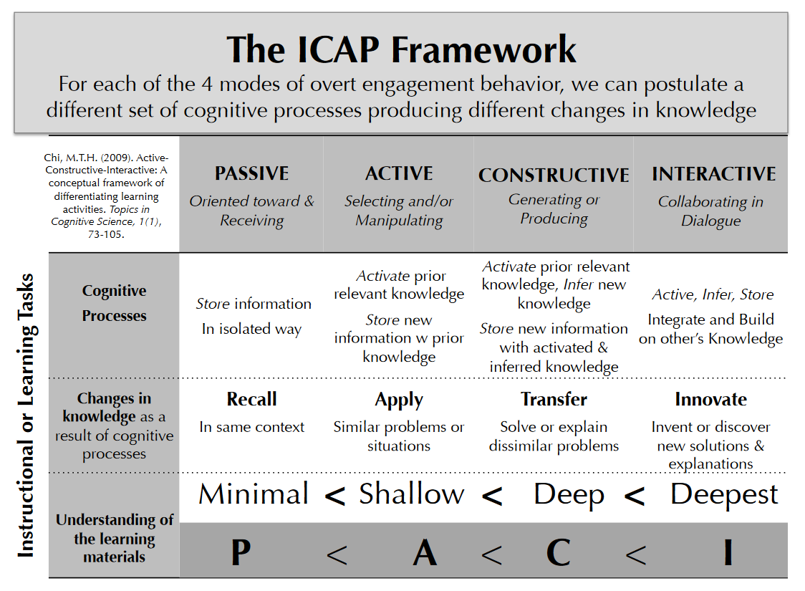  
Fig. 1. The conceptual taxonomy laid down by the Michelene T. H. Chi and Ruth Wylie to encompass the types of learning that students undertake.

Augmented Reality (AR) is interfacing with the surrounding environment by using camera technology to create a virtual layer on top of the environment. The only requirements are a device with enough computational power and a camera, allowing the user to see virtual objects and being able to interact with the physical realm.

Virtual Reality (VR) relies on immersing the user in a virtual environment completely independent of their surroundings; often with the interfacing done not through the virtual objects but through a controller (such as mouse and keyboard, or a gamepad). While the differences between AR and VR are purely domain-based, for the purposes of this paper we only reference AR – it is possible that our concepts, software solution, and overall assumptions fit the VR-space.

AR for the masses is a new technology, much of the long-term benefits, if any, in software applications, with respects to education, have not been thoroughly documented and verified thoroughly. Currently most studies suggest a positive correlation between AR and education; especially as a tool to teach or reinforce new topics in a novel, exciting, and interactive way [Hantono et al. 2016; Aguirregoitia et al. 2016; E-learning et al. 2016]. Furthermore, it has been shown that learning using AR promotes critical thinking skills and problem solving, in addition to promoting experiencing new ideas and topics that could otherwise not be done in the physical world; if an idea, too abstract to be properly represented by traditional pen-and-paper or chalk-and-board methods, new to students, could be represented in 3D space in a tangible and meaningful way, as an AR model, then positive benefits are to be expected with respects to the learning experience which is made more interesting, fun, motivating, and enjoyable while promoting cooperation and collaboration in the classroom setting [Hantono et al. 2016]. AR technology is most helpful in helping students who struggle to visualize intricate concepts and subjects: the ability to visualize the concept in 3D allows the student to gain new perspectives and insights to the inner functions of said concept [Hantono et al. 2016]. An AR application in the classroom setting, such as in a lab, could provide benefits to students, increasing motivation and learning autonomy while promoting Interactive and deep learning; the flexibility that such an application could bring to the classroom would allow for students to set their own learning goals and move at their pace, allow the instructor to define what to learn and the student to decide how to learn the material [Takatoshi Ishii, and Takako Akakura. 2016].

With respects to CSE, data structures can be tied directly to the Empirical Modeling (EM) learning methodology and epistemology which aims to make CSE less abstract and axiomatic, and more in-tune with how CS majors gain experience, through experience, or empirical knowledge gained from coding [Meurig, 2009]. EM is a conceptual framework for computing based on principles and tools for making construals. Construals are interactive digital artefacts that embody configurations of observables, dependencies and agencies encountered in the situations to which they refer to; within the context of CSE, construals describe emergent properties of axiomatic concepts. For example, a student can know the rules of Sudoku, but until they play it a couple of times—the concept will remain unfamiliar and purely abstract. In Sudoku, the construal is shaped by the constraints emerging from the rows, columns, and subdivided squares on the paper, culminating in the manifestation of the game’s rules as the player fills in the puzzle; the construals are the various strategies, observations, and learned tactics emerging from experiencing the game itself.

1. **AR SOFTWARE SOLUTION**

We made an application that displays Data Structure Visualizations (DSVs) in a novel way that supports the EM interactivity arising from the conceptualization and realization of Construals. With the goal of making something in 3D, interactive (as in allowing for students to interface with), and novel. By linking Data Structures to their respective DSV, we hope to create a memorable and cogent presentation that aids instructors in the classroom, to make planning easier and increase overall student engagement.

Vuforia was used on the back-end as the image processing and fiducial marker generator. Using their cloud-server technology a desired image (the only requirement being that said image was high quality) to their servers, and they took care of the image-recognition and machine-language training by generating a device image database and a cloud target database to integrate with Unity (see Figure 2). Once we had that, we created textures and animations to rig to the specific marker. Then using the animations, we created Scenes in Unity, as well as the UI experience that modeled the desired interaction.

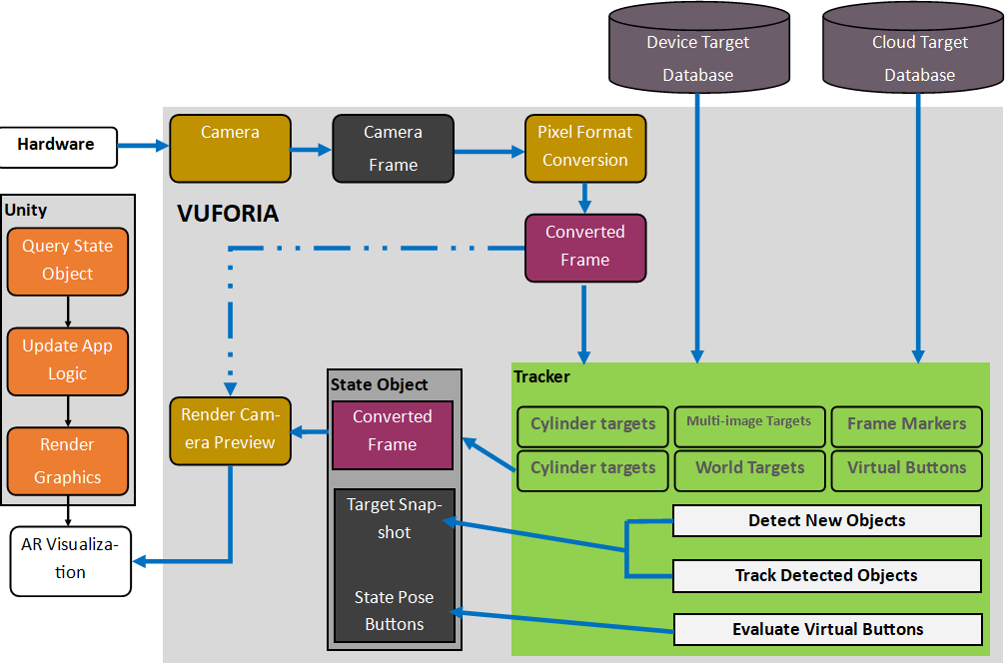

Fig. 2. The system design architecture: a camera is pointed at an AR marker which Vuforia interprets and Unity renders (if a scene is attached to the marker).

To determine how a DSV is modeled we used the following approach:

1. Model its properties and emergent characteristic.
2. Study its application and importance in the classroom setting.
3. Model the resulting emergent characteristics with respects to the student and the expected learning outcome.

We modeled the most basic data structure: the array. Using the approach described above we thus got:

1. Array: a container object holding a fixed number of values of a single datatype.
   1. Length established at creation.
      1. After creation, length is static (fixed).
   2. Composed of elements.
   3. Accessed by its numerical index.
2. Arrays form the most basic building blocks in CSE.
3. Following emergent characteristics:
   1. Arrays differ in number of elements and index.
      1. There cannot be 0 elements, but your index starts at 0.
      2. Static at creation, user must preempt size.
   2. Arrays are bounded.
      1. Out-of-bounds possible.

See Figure 3 to see our array visualization.

Within the context of the ICAP framework, our application allows students to view and interact with a DSV; students using this will thus engage in Interactive learning as they both are received instruction from a professor and from the application itself which targets the construals 3(a) and 3(b) which are emergent properties of arrays.

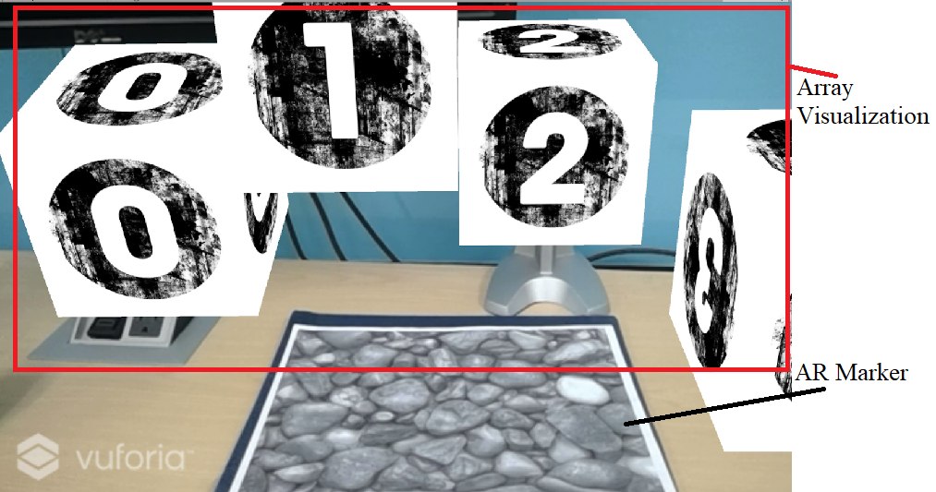

Fig. 3. The DSV from the perspective of the student; index 0 – 3 is displayed.

1. **CONCLUSION**

The use of AR tools in CSE could provide tangible benefits to beginner students. While effective, it should be noted that it is possible for the student to lose interest in the application after repeated use. Thus, it is suggested that the application be used in conjunction with lectures or other similar aides. The application should serve as a tool to assist in the learning process and should not at any point, replace the human interaction between the Student and Teacher. Although some studies do suggest that computer tutors could service students just as effectively.

In the future, we hope that our software can be more feature-complete encompassing all data structures properly. To effectively measure, through the AAA methodology, student engagement. Obviously, the limitations present are due to the infancy of the Vuforia technology and limited available computational power, since our solution ultimately aims to be as cost effective as possible so that it is adopted by schools *en masse* (where cost does matter).

**REFERENCES**

KURT VanLEHN (2011) The Relative Effectiveness of Human Tutoring, Intelligent Tutoring Systems, and Other

Tutoring Systems. *Educational Psychologist*, 46, 4, 197-221

Michelene T. H. Chi and Ruth Wylie. 2014. The ICAP Framework: Linking Cognitive Engagement to Active

Learning Outcomes. *Educational Psychologist*. 49, 4, pp. 219-243.

Sidney D'Mello, Ed Dieterle, and Angela Duckworth. 2017. Advanced, Analytic, Automated (AAA) Measurement

of Engagement During Learning. *Educational Psychologist*. 52, 2, pp. 104-123.

Beynon Meurig. 2009. Constructivist Computer Science Education Reconstructed. *Innovation in Teaching and*

*Learning in Information and Computer Sciences.* 8, 2, pp. 73-90.

Bimo Sunarfri Hantono, Lukito Edi Nugroho, and P. Insap Santosa. 2016. Review of Augmented

Reality Agent in Education. *6th International Annual Engineering Seminar (InAES),*

*Yogyakarta, Indonesia*. IEEE, 978-1-5090-0741-7.

Aguirregoitia Martínez, Amaia Allende López, Iñigo López Benito, and Jorge R. Artetxe

González. 2016. Enara. Leihoa: A window to Augmented Reality in Early childhood

Education. *Computers in Education (SIIE), 2016 International Symposium on.* IEE, 978-

1-5090-4596-9.

Takatoshi Ishii, and Takako Akakura. 2016. A model and evaluation method of learning

motivation in the education and training of professional engineers. 2016 IEEE

International Conference on Teaching, Assessment, and Learning for Engineering

(TALE), Bangkok, pp. 311-318. 978-1-5090-5598-2.

Darina Dicheva, Austin Hodge, Christo Dichev, and Keith Irwin. 2016. On the Design of an

Educational Game for a Data Structures Course. 2016 IEEE International Conference on

Teaching, Assessment, and Learning for Engineering (TALE), Bangkok, pp. 14-

17. 978-1-5090-5598-2.

Meurig Beynon. 2009. Constructivist Computer Science Education. Reconstructed, Innovation in Teaching and

Learning in Information and Computer Sciences. 8, 2, pp. 73-90.